[Date]

Kyer Potts

30003389

Database Programming AT1.4

Hotel Database

1. List all the guests that have a first name that begins with “M”.
   1. SELECT * FROM guest WHERE guestName LIKE "M%"
   2. 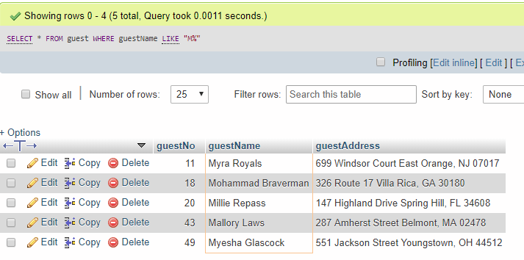
2. List all the double rooms with a room number greater than 3000.
   1. SELECT * FROM ROOM WHERE type = "double" AND roomNo > 3000
   2. 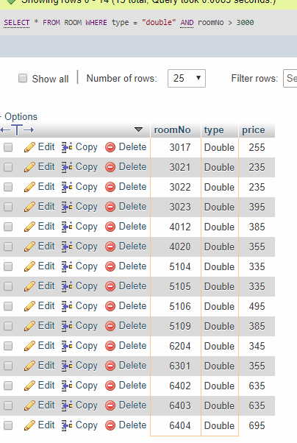
3. How much would it cost to stay in room 6402 for 7 days
   1. Select price * 7 FROM room WHERE roomNo = 6402
   2. 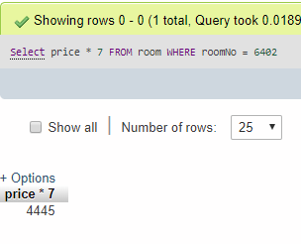
4. List all the single rooms that cost less than $200 per night (order by room number descending)
   1. SELECT * FROM room WHERE type = "single" AND price < 200 ORDER BY roomNo DESC
   2. 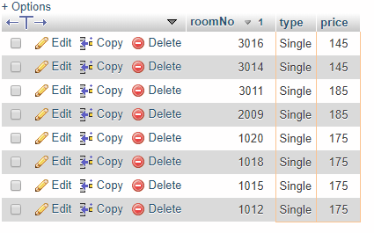
5. List all the rooms that are not singles and cost less than $250
   1. SELECT * FROM room WHERE price < 250 AND type != "single"
   2. 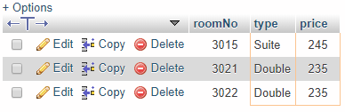
6. 6. List all the double rooms that cost more than $660 or less than $250
   1. SELECT * FROM room WHERE type = "double" AND (price > 660 OR price < 250)
   2. 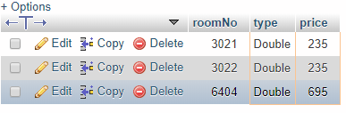
7. How long did guest number 35 stay in room 6303
   1. SELECT DATEDIFF(dateTo, dateFrom) FROM booking WHERE guestNo = 35 AND roomNo = 6303
   2. 
8. What was the total cost for guest number 40 when they stayed in room number 6204?
   1. SELECT room.price * DATEDIFF(booking.dateTO, booking.dateFrom) AS Total_Cost FROM room, booking WHERE booking.guestNo = 40 AND booking.roomNo = 6204 AND room.roomNo = 6204
   2. 
9. List only the booking details (Booking number, DateForm, DateTO and Room Number) for Wilbert Crafford
   1. SELECT bookingNo, DateFrom, DateTo, roomNo FROM booking LEFT JOIN guest ON booking.guestNo = guest.guestNo WHERE guest.guestName = "Wilbert Crafford"
   2. 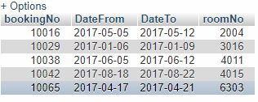
10. List all the details of guests (GuestName, GuestAddress, BookingNo, DateFrom and DateTo) who have stayed in room number 2007
    1. SELECT guest.guestName, guest.guestAddress, booking.bookingNo, booking.dateFrom, booking.dateTo FROM booking RIGHT JOIN guest ON booking.guestNo = guest.guestNo WHERE booking.roomNo = 2007
    2. 